## Glider Operations:

##### RUNWAY 32;

Normally, Gliders operate from the grass on the south east side of Runway 32 near the clubhouse trailer, for most takeoffs and landings, up to a 10 Knot tailwind (by agreement with the other users of the Airport). This allows for a more efficient operation. We may use a higher tailwind for training purposes. Use caution for power traffic when doing so.

We refer to the runway as 32, because it is orientated on a 320 degree magnetic heading. The prevailing wind for this airport is approximately from the Northwest (320 degrees).

**Stage** the gliders with tails toward the East side fence, (tied down if leaving the glider unattended), nose into the wind.

**Ready for Launch:** Once the glider has been pre-flighted, checklists completed, and ready for launch, move the glider to the takeoff area.

**Takeoff:** should use the grassy area closest to the clubhouse. Ensure the glider and tow will clear any other gliders if the wing should drop while launching, or any other problem develop.

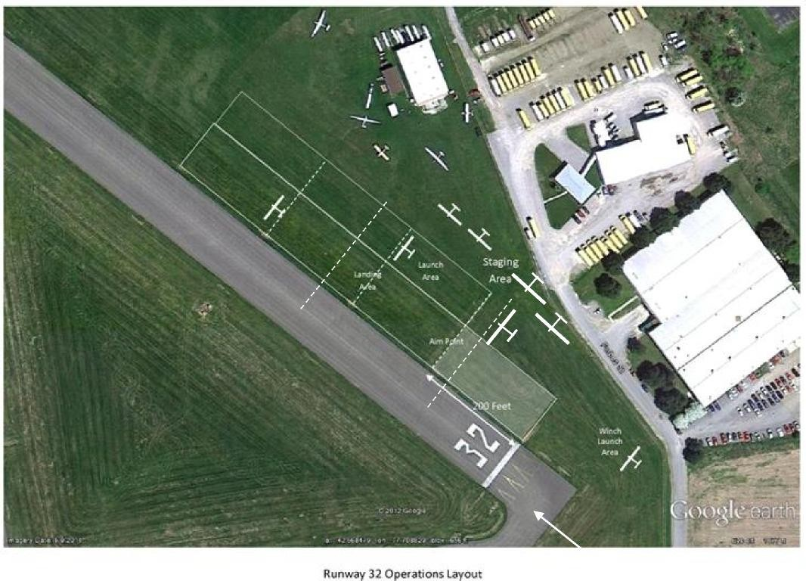

t