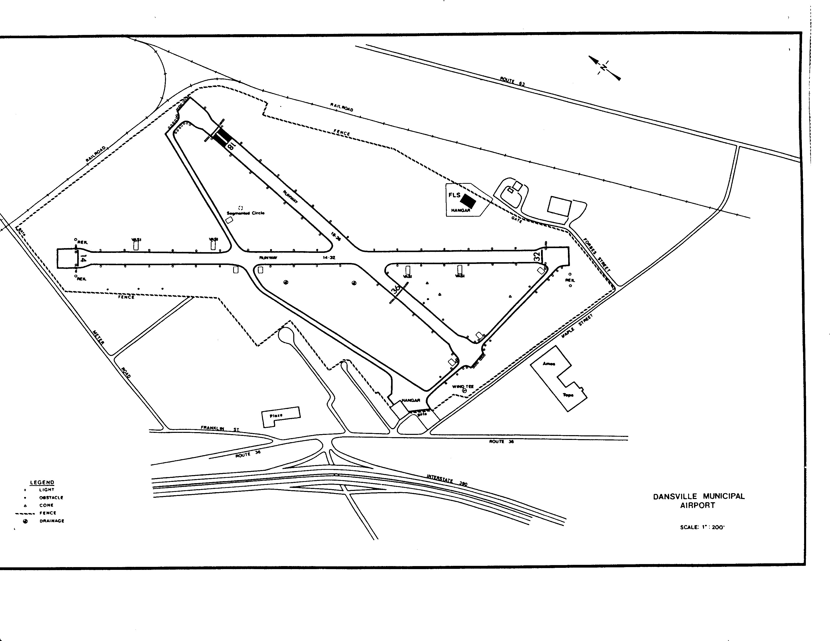
Unlandable
Good Surface
Bumpy but
Usable
Launch/Land
Relights

